**Amazon AWS Part Two**

**Lab 4 – Working with EBS**

**Lab 5 – Build a Database Server**

**Lab 6 – Scale & Load Balance your Architecture**

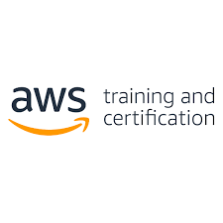

By, Liam Gilmartin.

**Purpose -** The purpose of this lab was to complete the second three Amazon AWS labs and master their components, which includes creating a management console, security groups, volumes, databases, and subnet groups.

**Background Information on Lab Concepts –**

* Amazon EBS allows for persistent storage for Amazon EC2 instances. Amazon EBS volumes are network-attached and persist independently from the life of an instance. Amazon EBS volumes are highly available, highly reliable volumes that can be leveraged as an Amazon EC2 instances boot partition or attached to a running Amazon EC2 instance as a standard block device.
* Amazon RDS is easy to operate and scale a relational database in the cloud. It provides cost-efficient and resizable capacity while managing time-consuming database administration tasks, which allows you to focus on your applications and business. Amazon RDS provides you with six familiar database engines to choose from.
* Elastic Load Balancing automatically distributes incoming application traffic across multiple Amazon EC2 instances. It enables you to achieve fault tolerance in your applications by seamlessly providing the required amount of load balancing capacity needed to route application traffic. Auto Scaling helps you maintain application availability and allows you to scale your Amazon EC2 capacity out or in automatically according to the conditions you define. Auto Scaling can be used to help ensure that you are running your desired number of Amazon EC2 instances. Auto Scaling can also automatically increase the number of Amazon EC2 instances to maintain performance. Auto Scaling is well suited to applications that have stable demand patterns.

**Lab Summary -**

* To successfully complete this lab, you should be familiar with basic Amazon EC2 usage and with basic Linux server administration. You should feel comfortable using the Linux command-line tools. This lab focuses on Amazon Elastic Block Store (Amazon EBS), a key underlying storage mechanism for Amazon EC2 instances. In this lab, you will learn how to create an Amazon EBS volume, attach it to an instance, apply a file system to the volume, and then take a snapshot backup.
* This lab is designed to reinforce the concept of leveraging an AWS-managed database instance for solving relational database needs.
* This lab walks you through using the Elastic Load Balancing (ELB) and Auto Scaling services to load balance and automatically scale your infrastructure.

**Lab Commands -** The second three introductory AWS labs did not contain any single commands.

**Network Diagram with IP’s -**

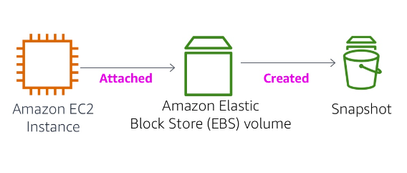

This is the overview image for the 4th AWS lab. ^^

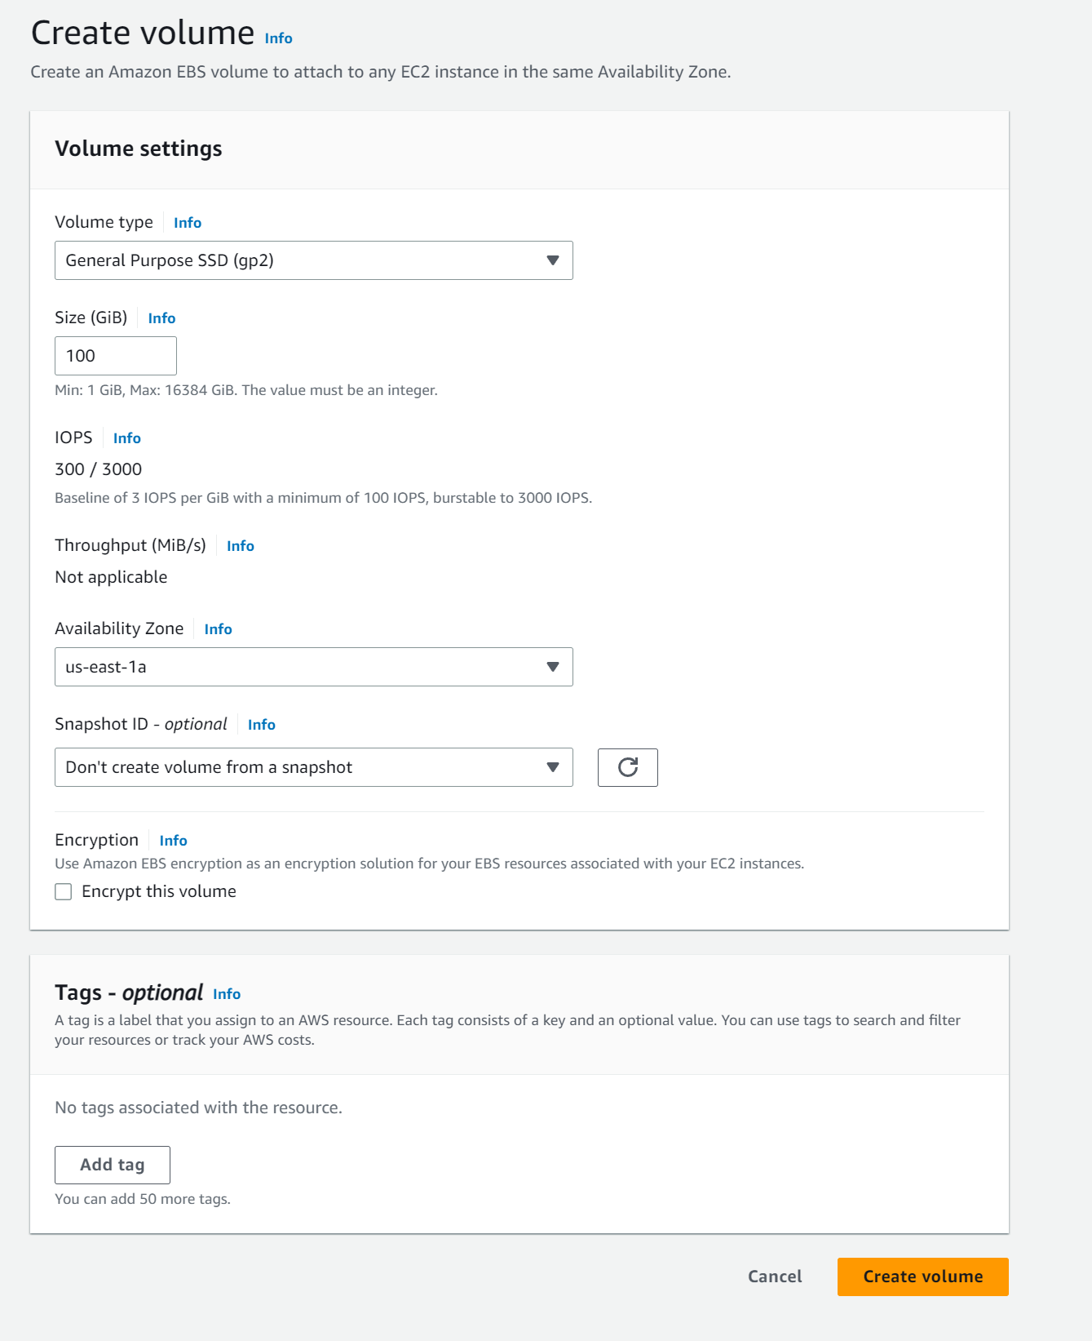First, I will configure the volume.

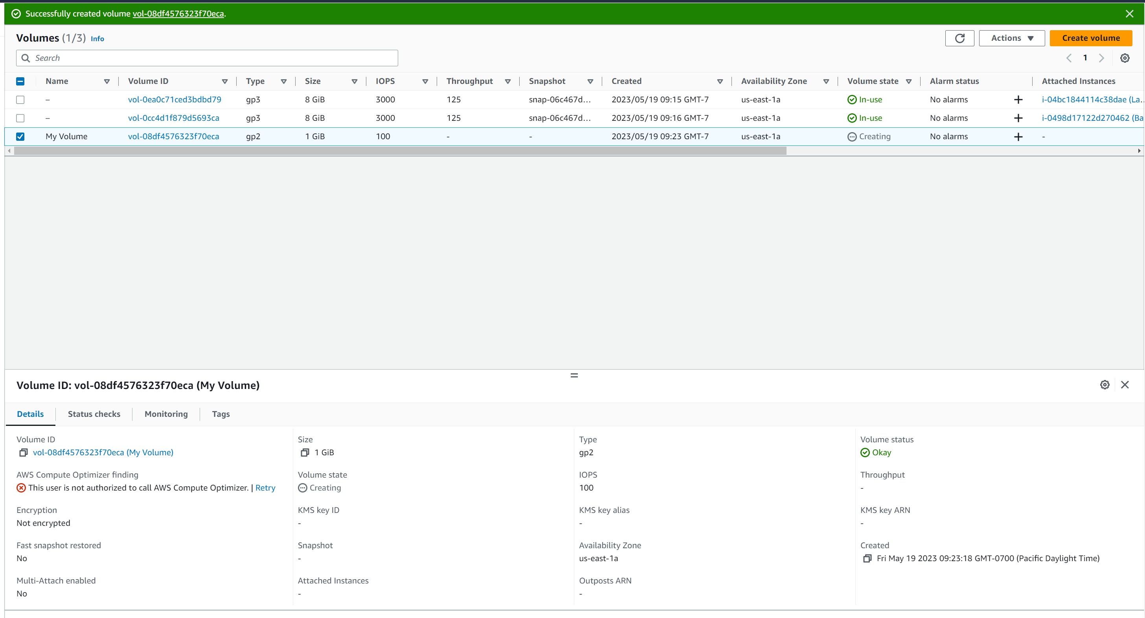

Created a volume, named “My Volume”. ^^^

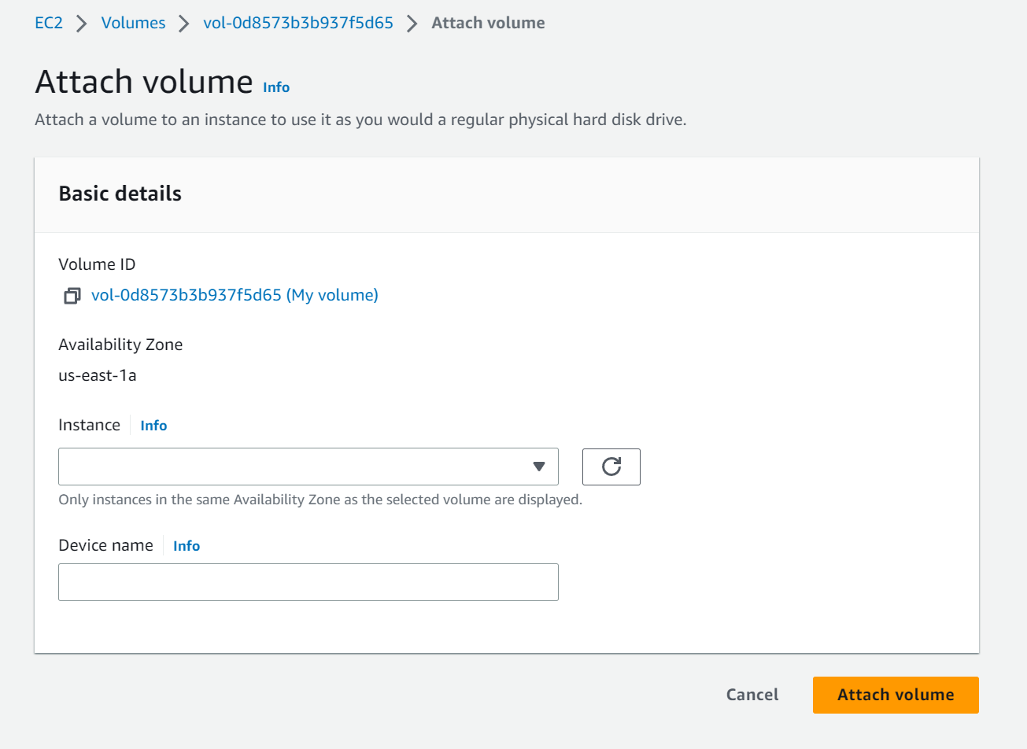

Attaching volume to instance. ^

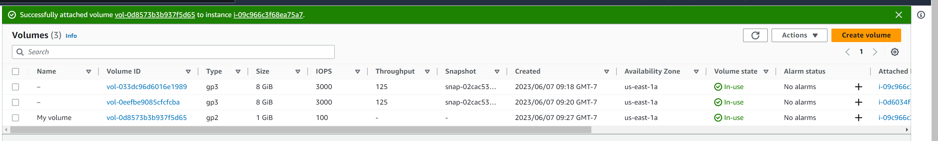

Volume is now attached to an instance. ^^

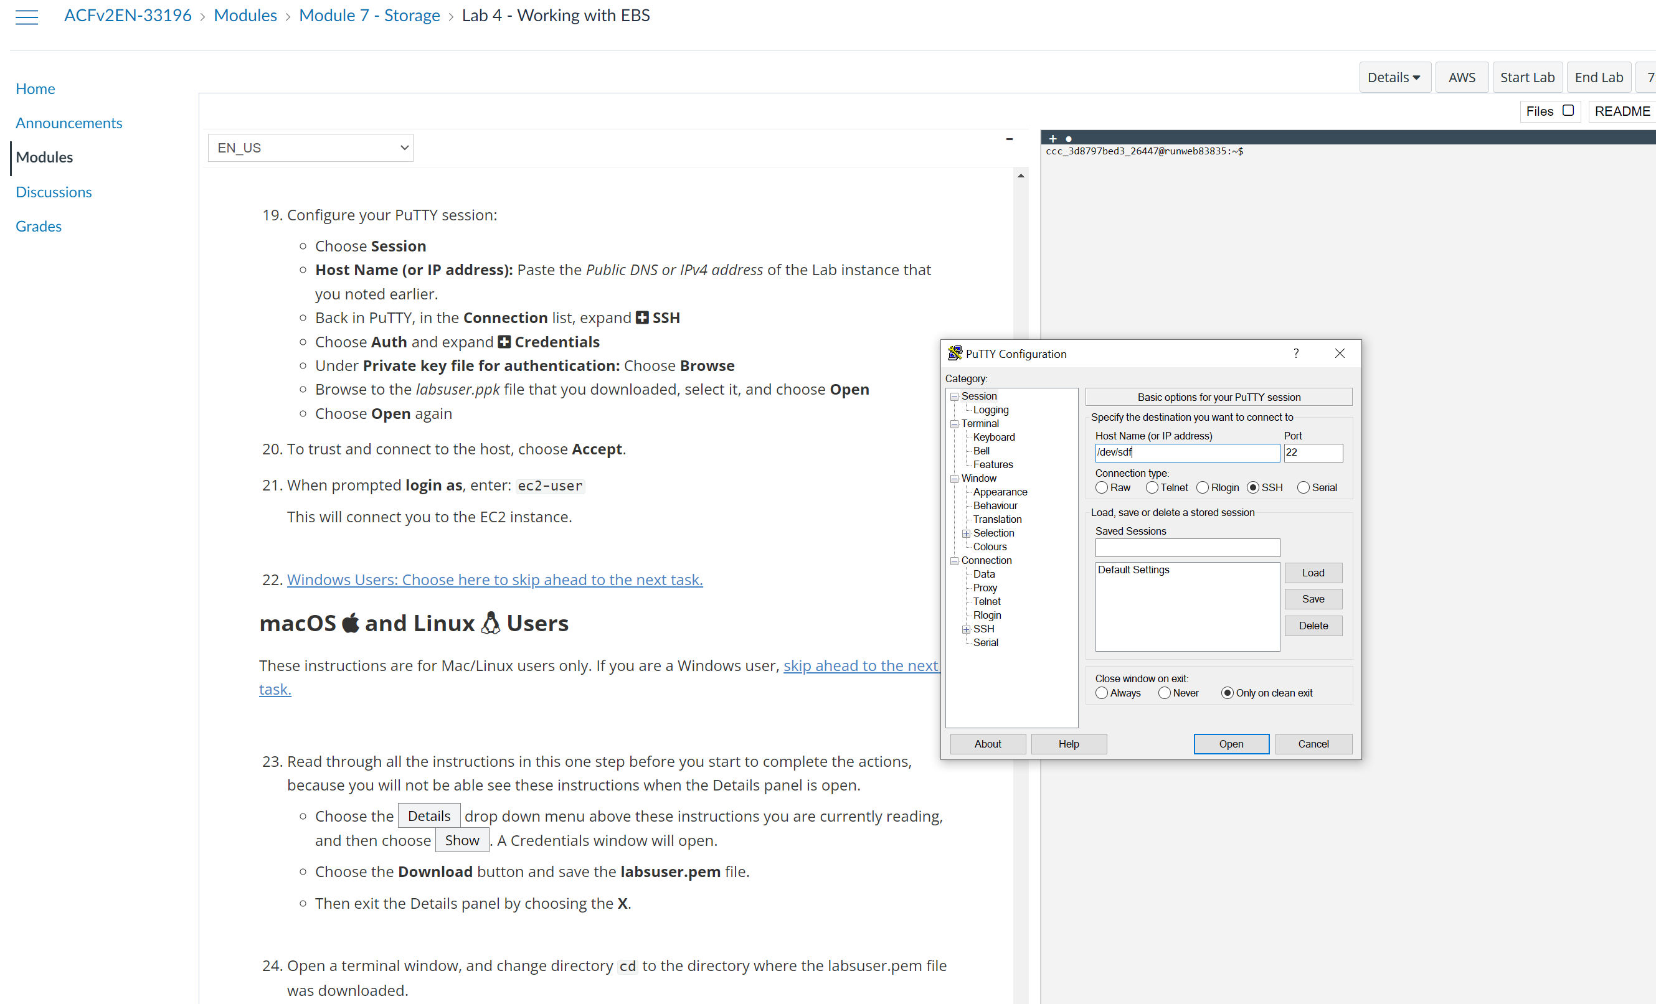

Configuring putty not to time out. ^^

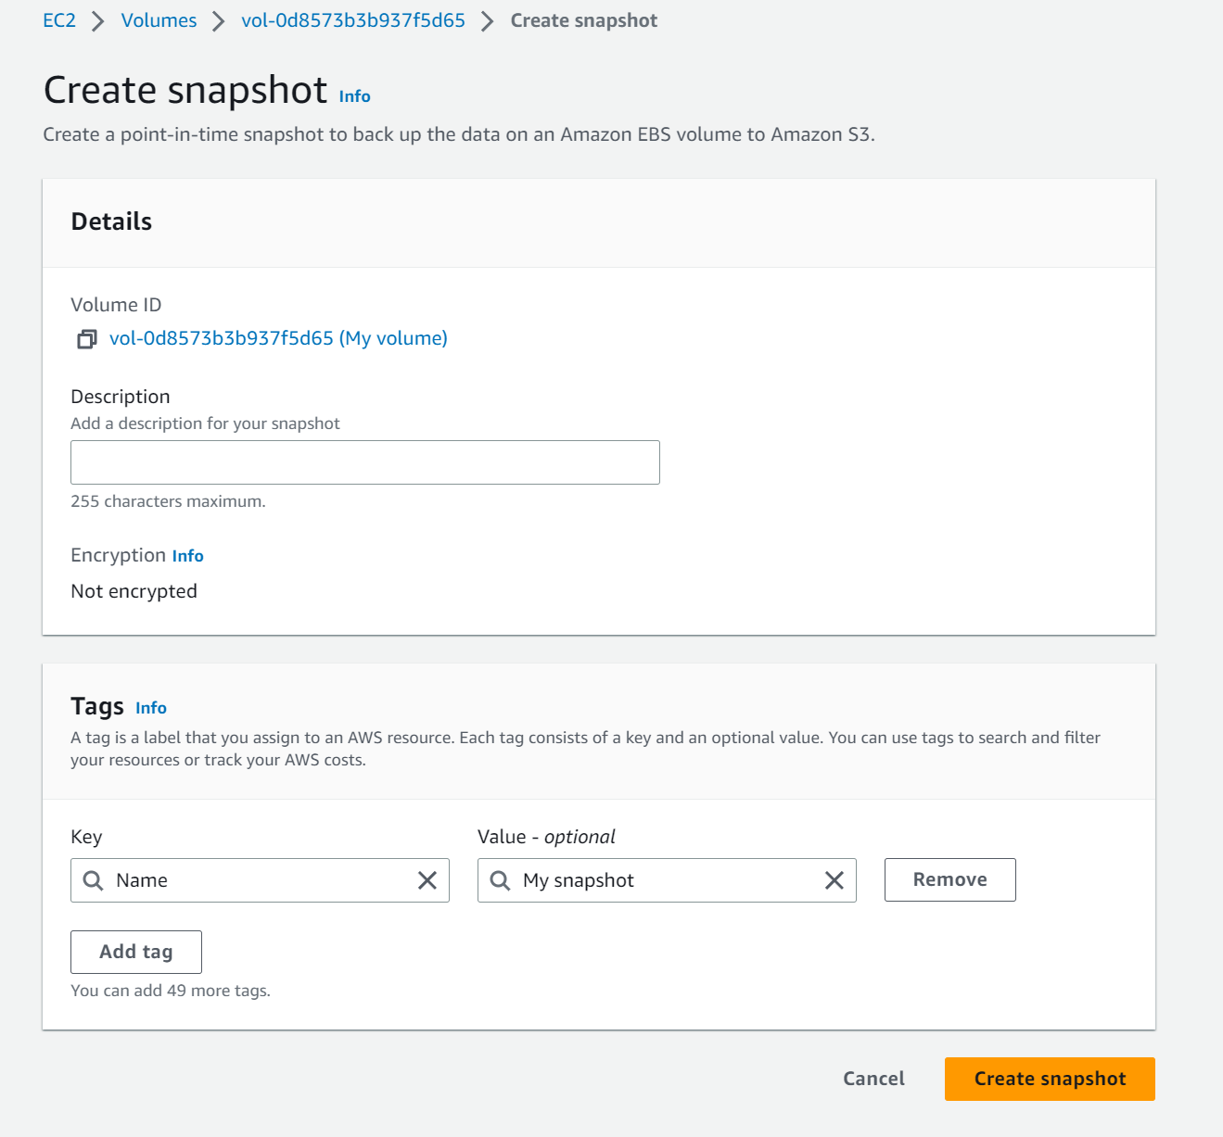

Creating snapshot. ^^^^^

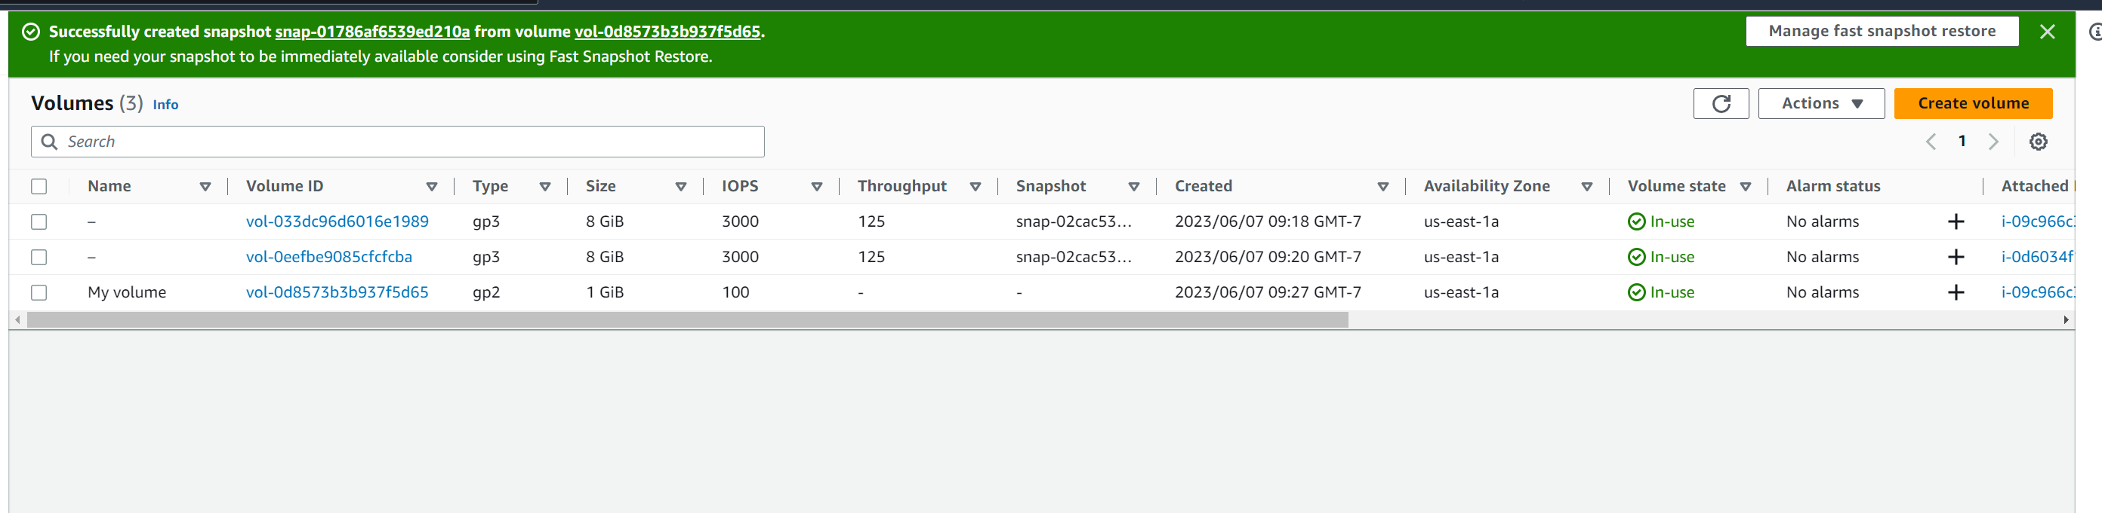

Snapshot created. ^^^^^

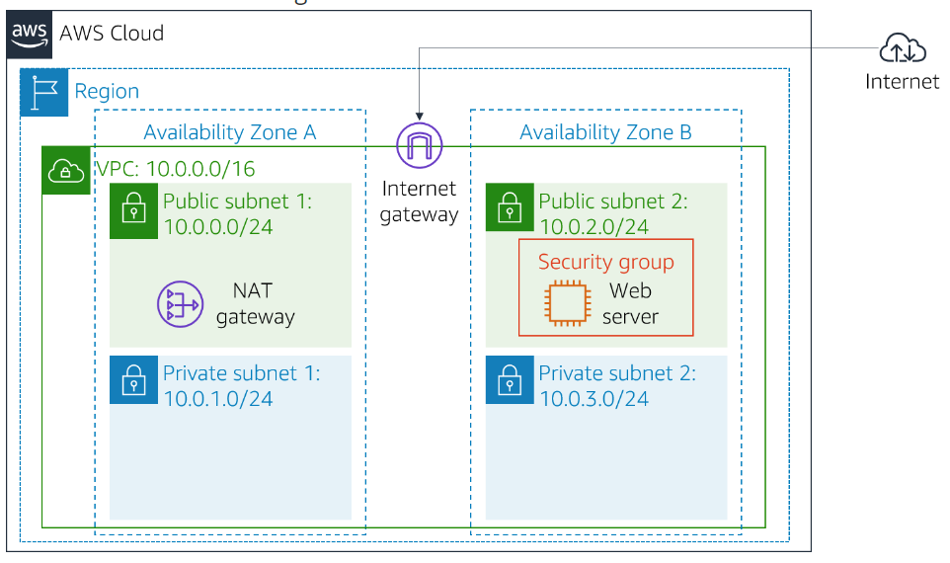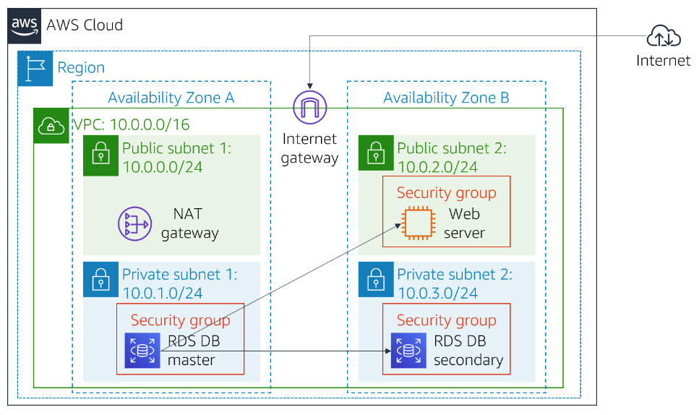

These two images are the overview images for the 5th lab. ^^^^^

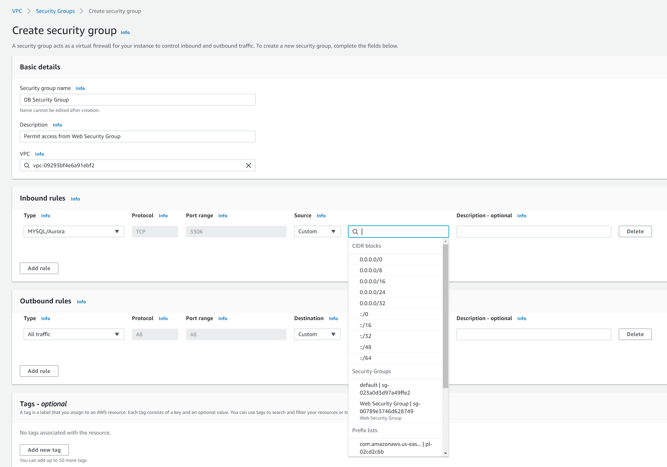

Configuring security group. ^^ 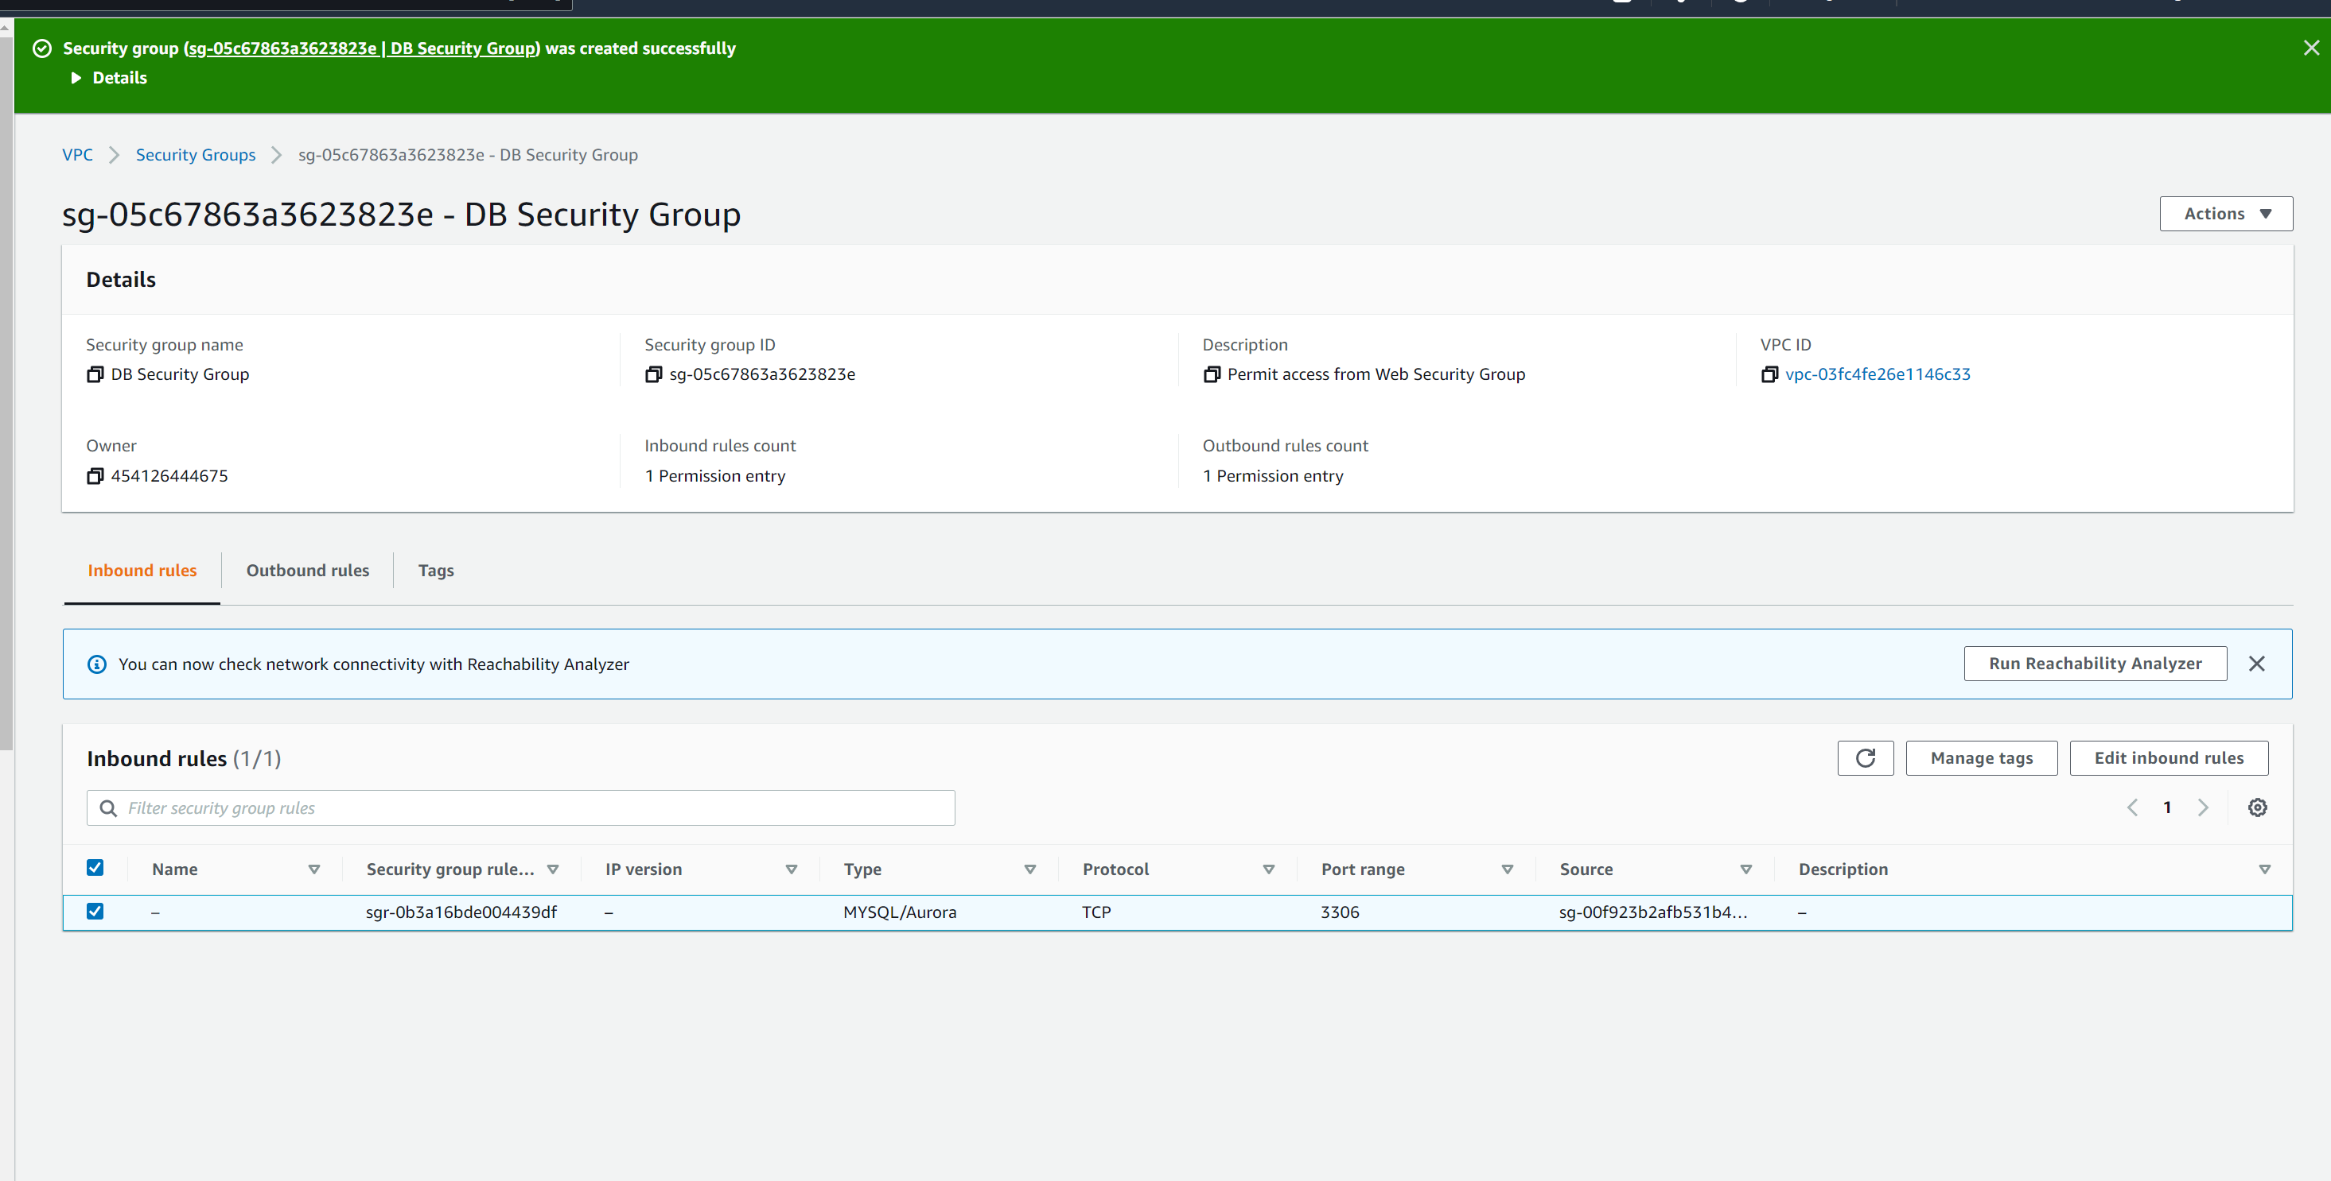Successfully created a security group, named “DB Security Group”. ^^

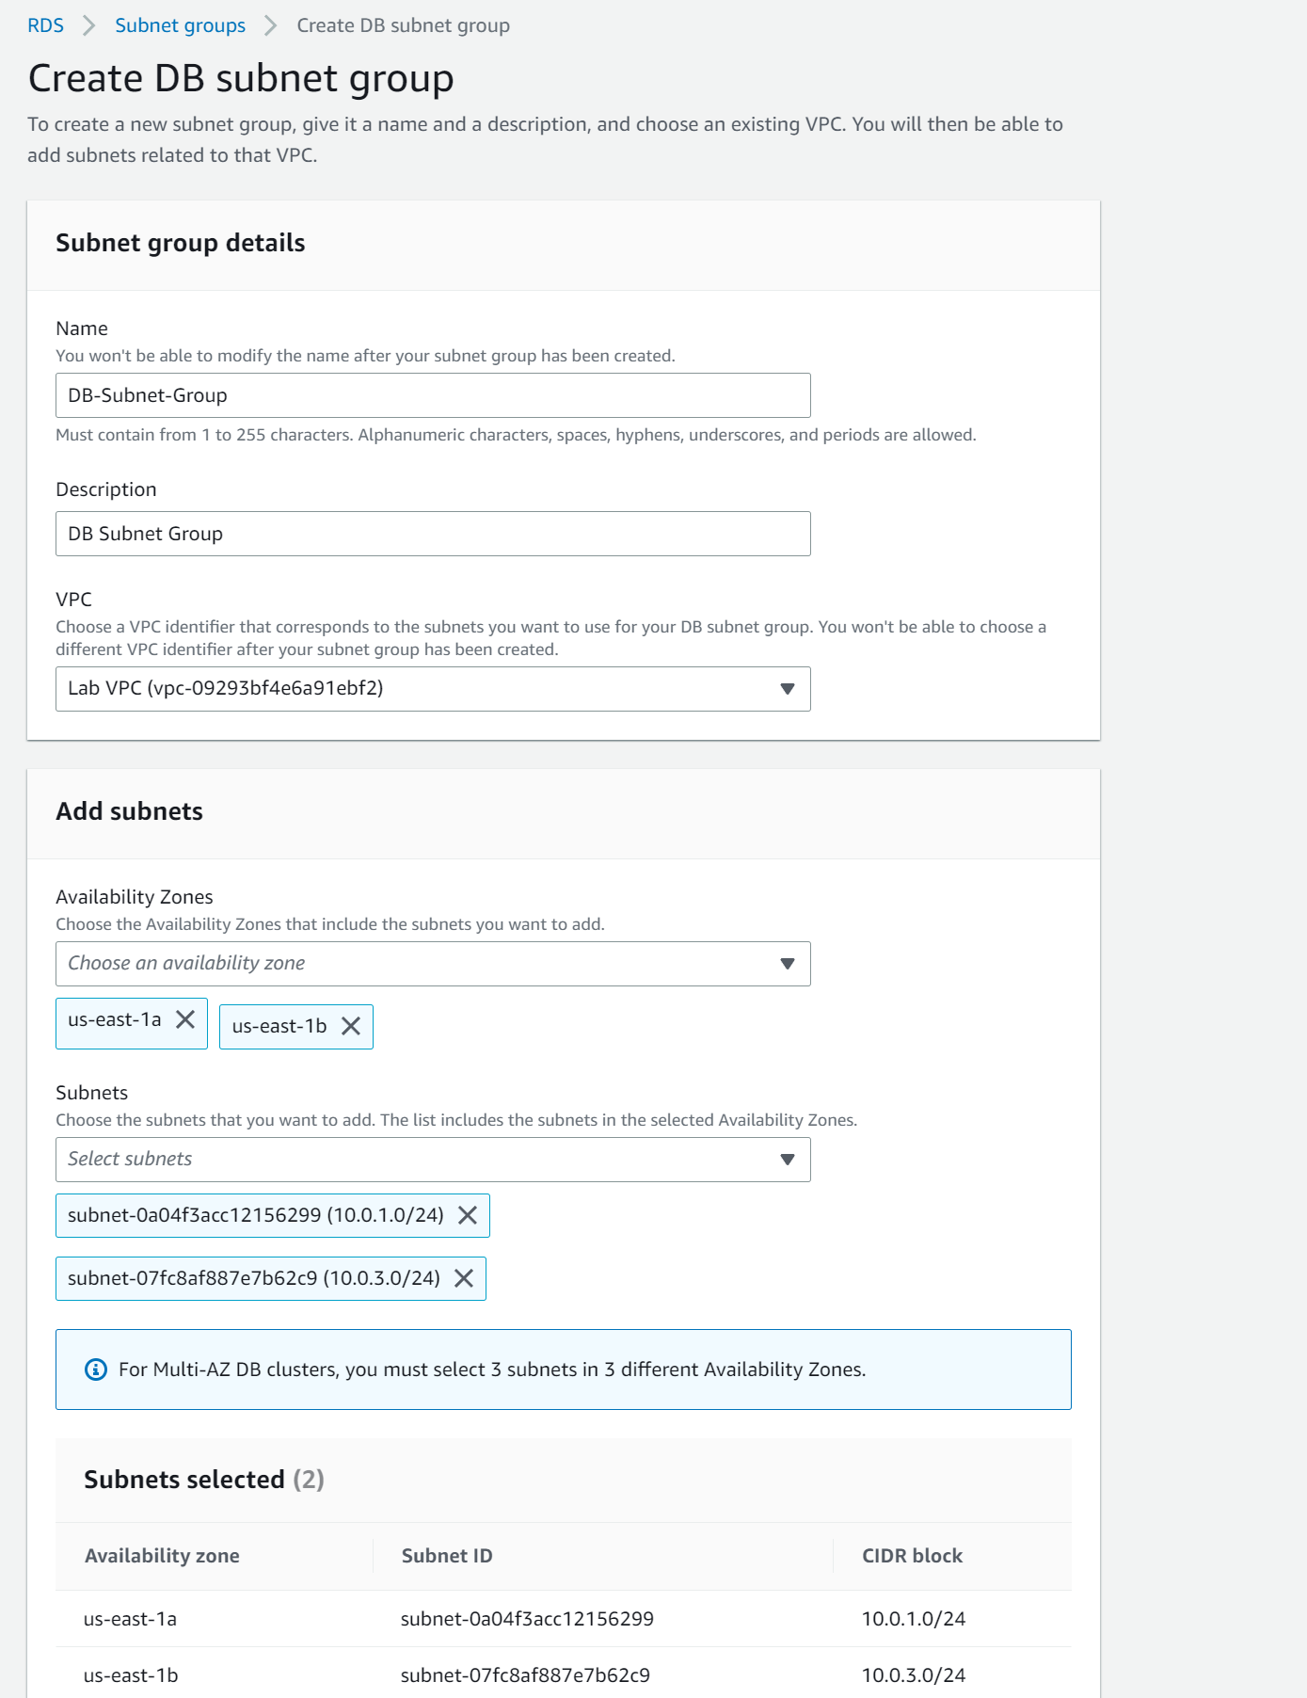Configuring DB subnet group.

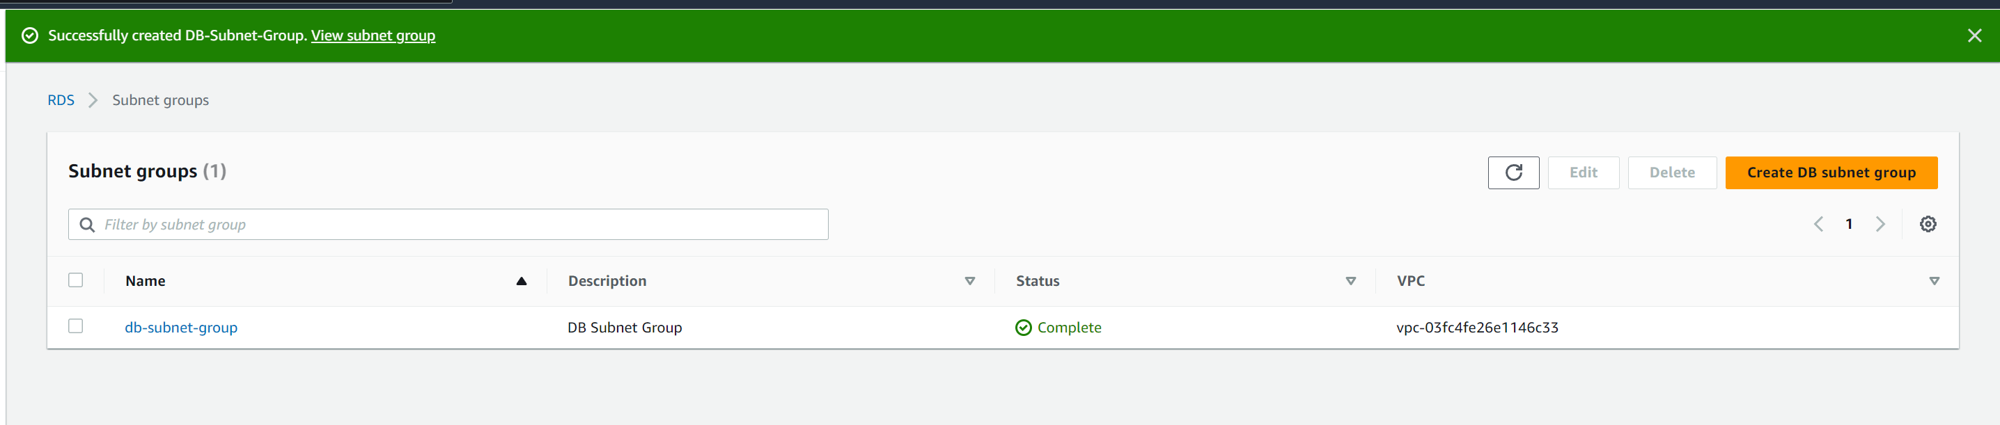Created a DB subnet group, named “DB-Subnet-Group". ^^

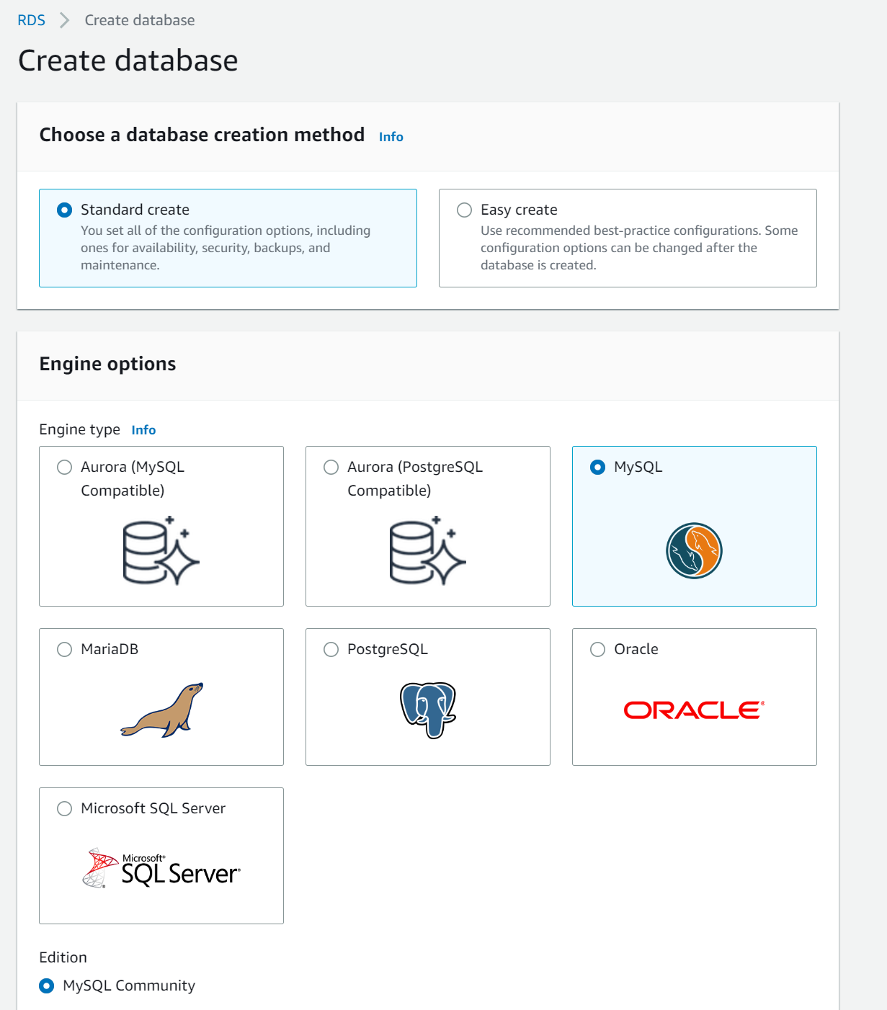Configuring engine option for database.

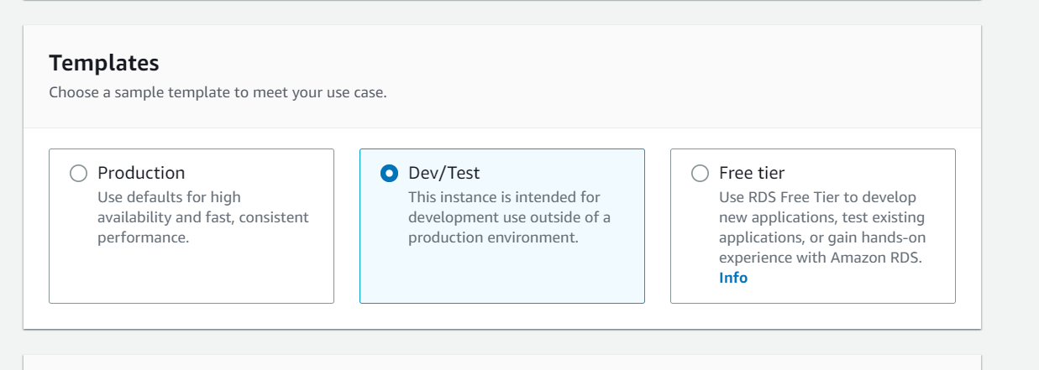Configuring template for database. ^^

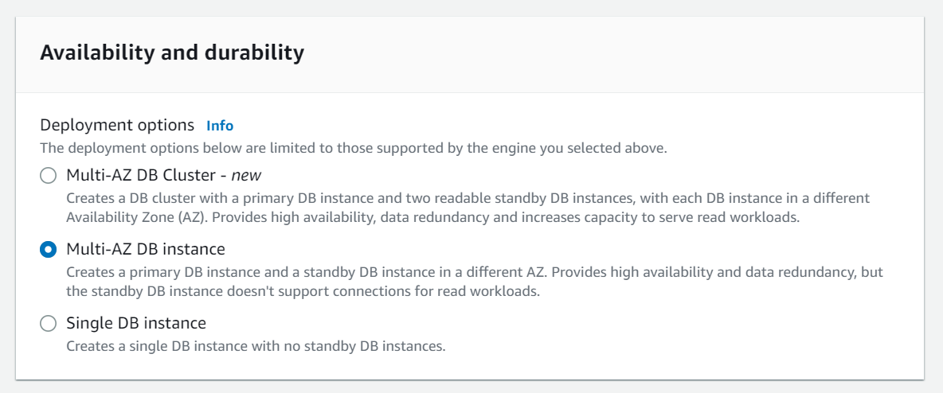

Selecting the availability and durability for database. ^^

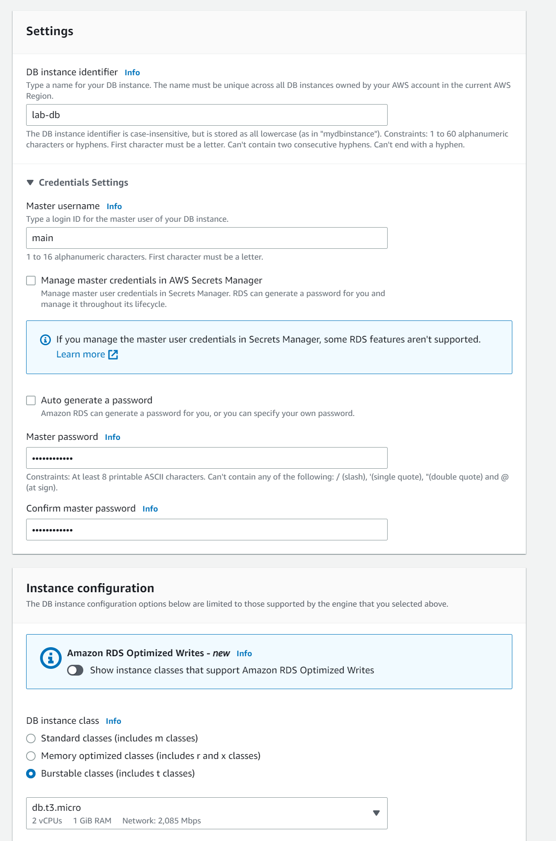 Configuring overall settings for database.

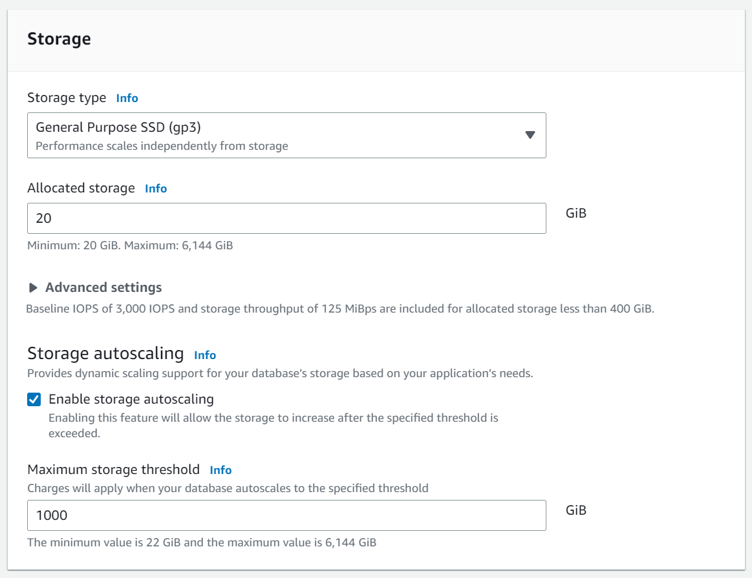 Configuring storage for database. ^^

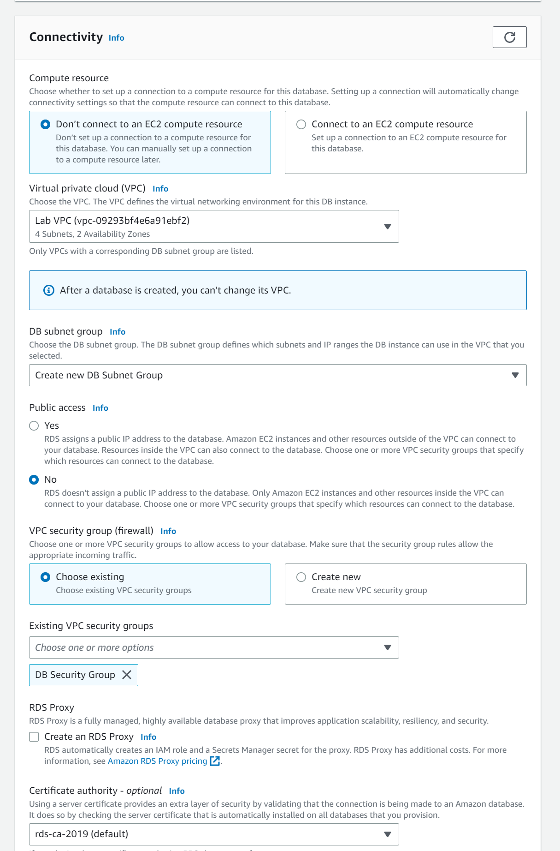Configuring connectivity for database.

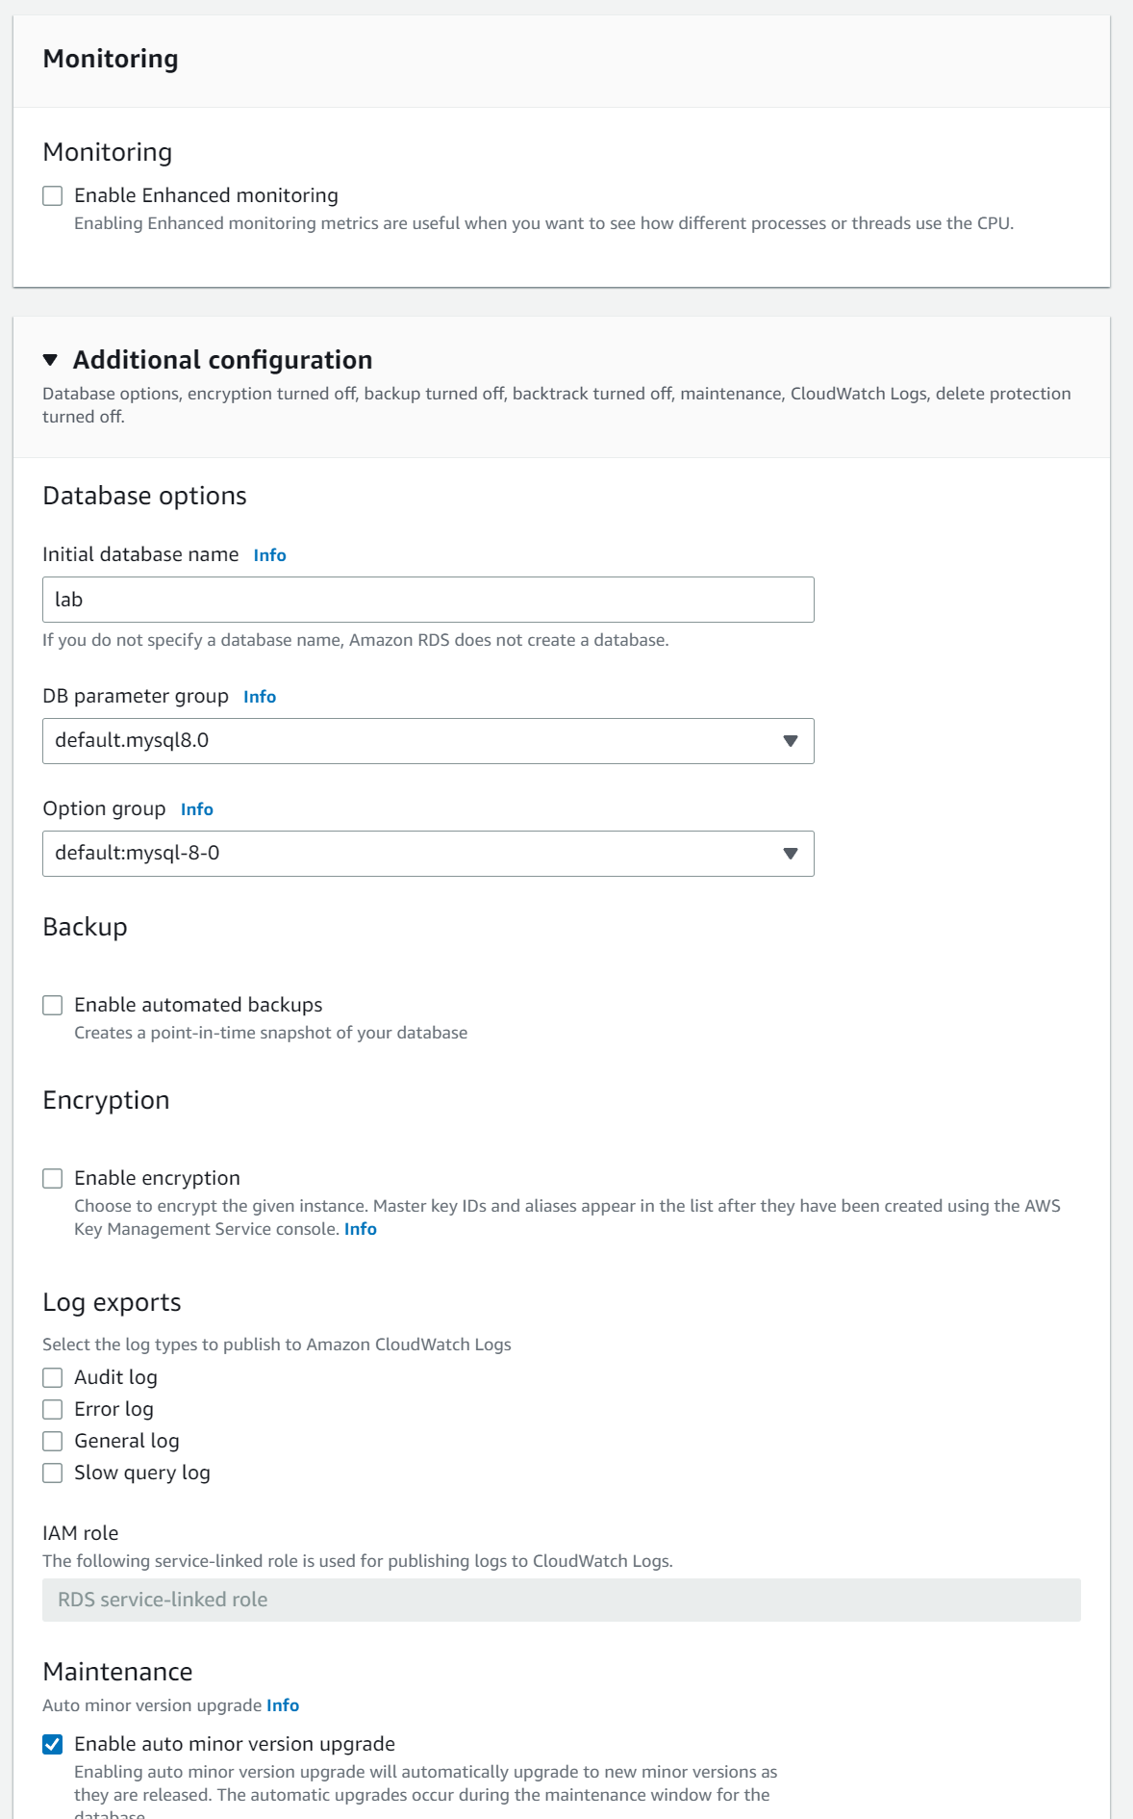Turned off enhanced monitoring and finished additional configurations. ^^

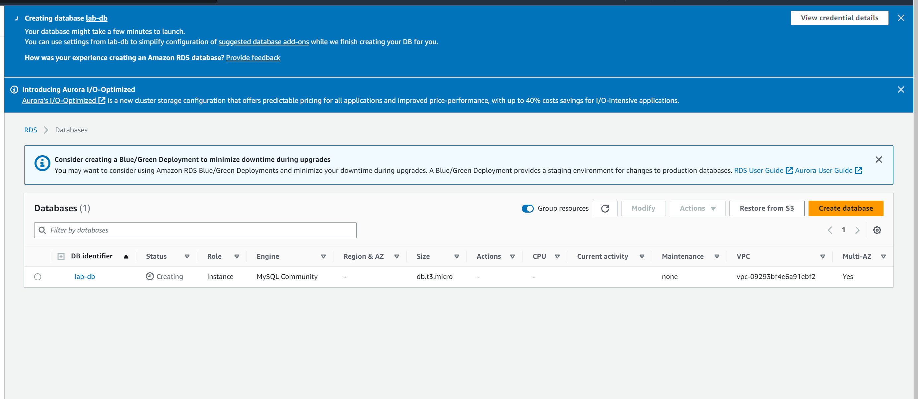

Database in creation. ^^

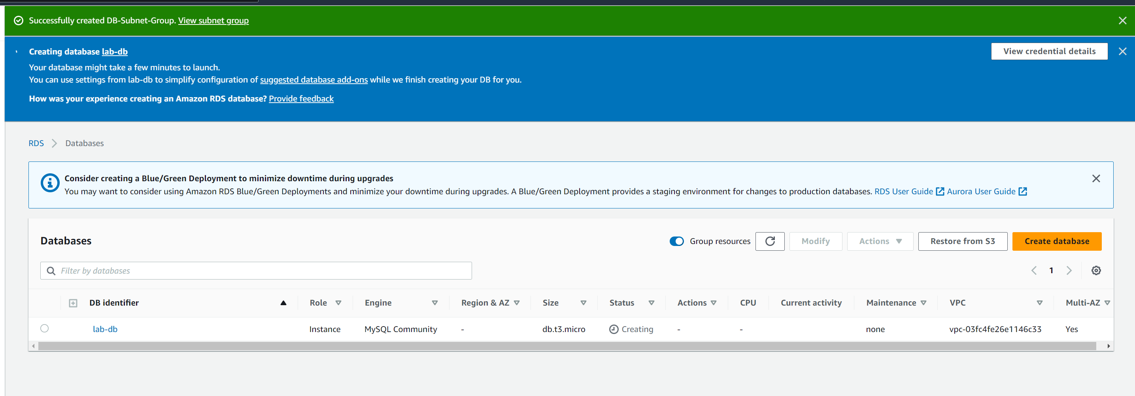Created a database. ^^

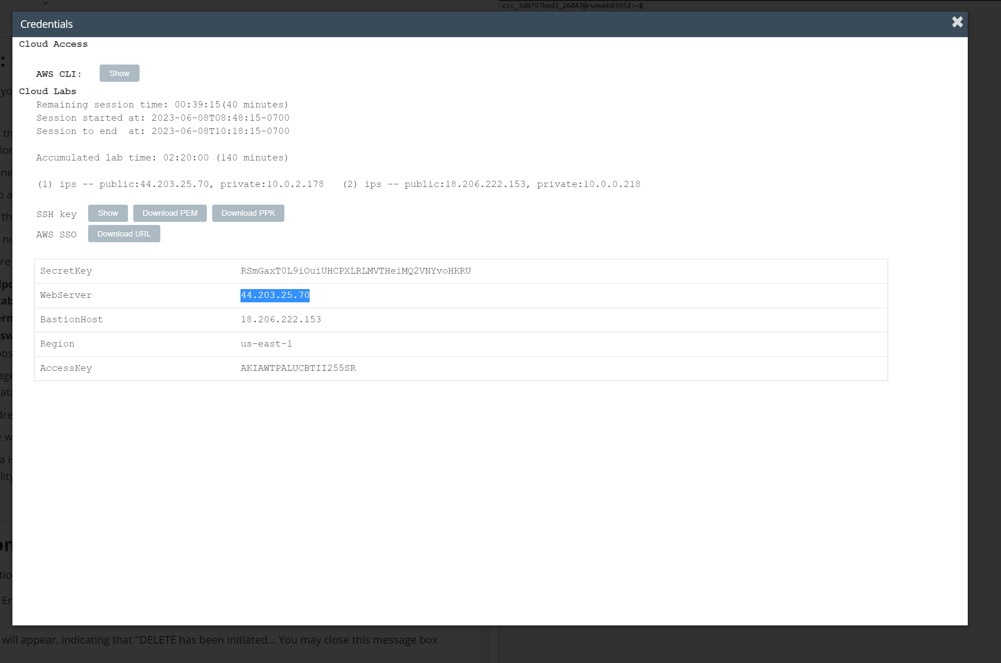

Credential screen within lab instructions. Copying web server Ip. ^^

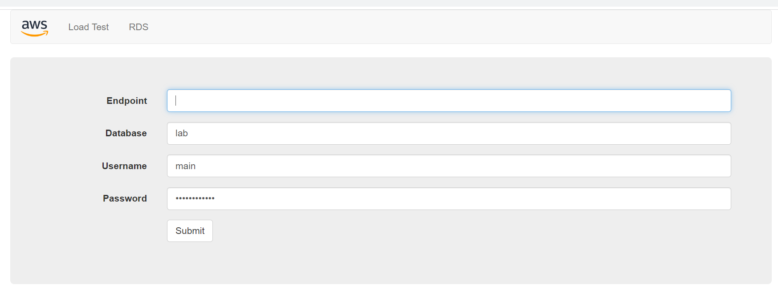

Performing load test for the Web Server. ^^

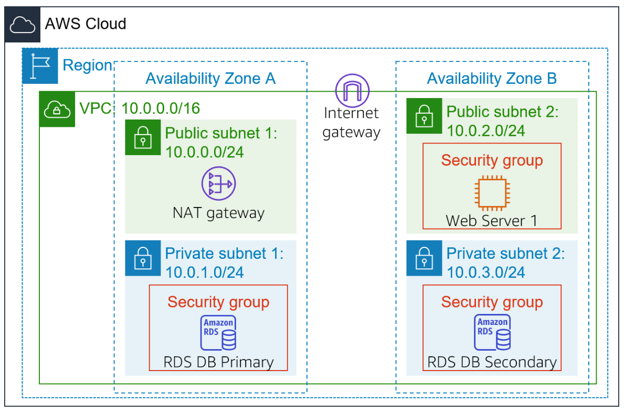

This is what your lab should look like when beginning. ^^

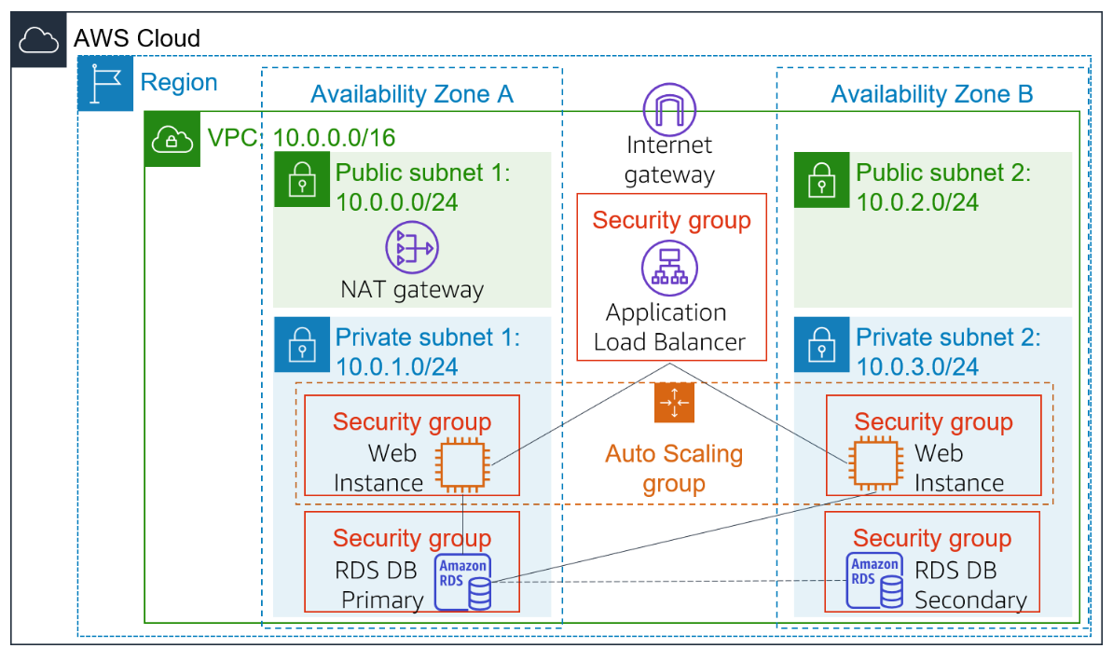

This is what your lab should look like when finished. ^^

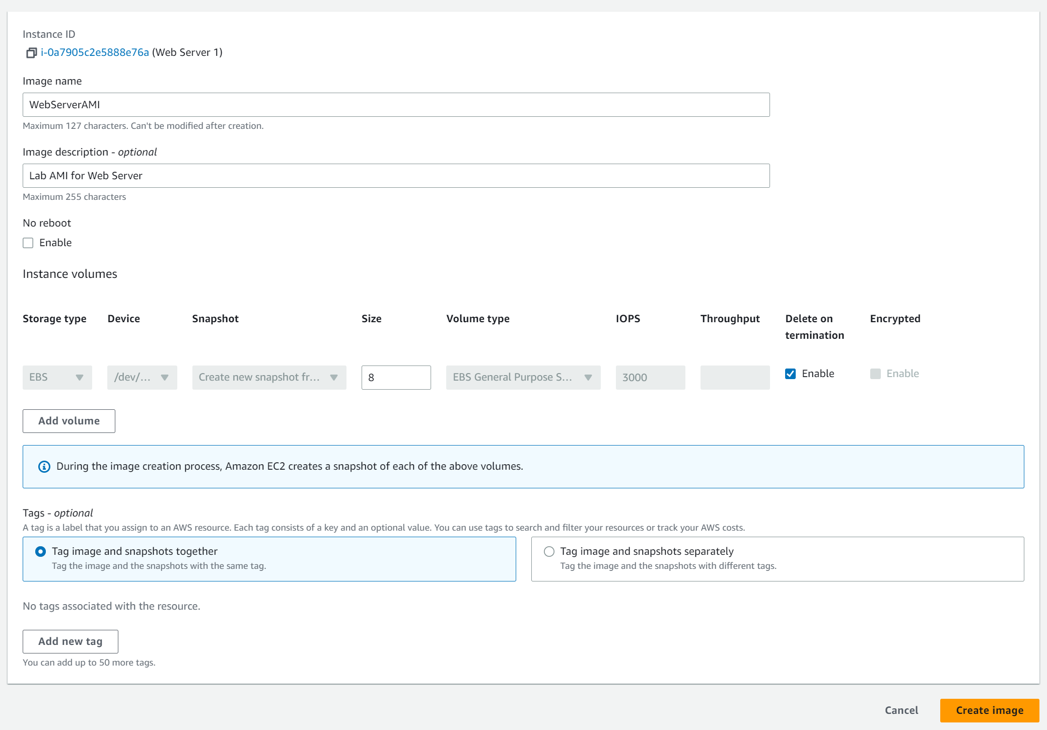

Configuring image. ^^^

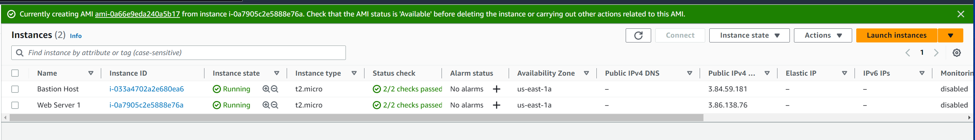

Image created. ^^

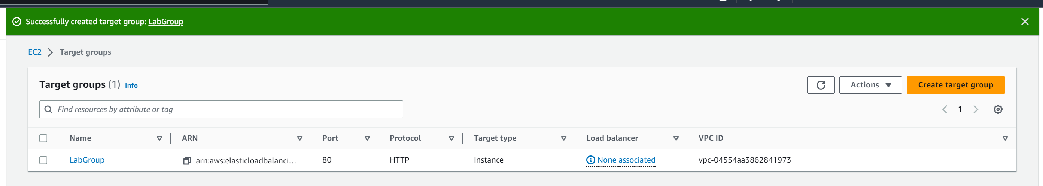

Successfully created a target group. ^^^^

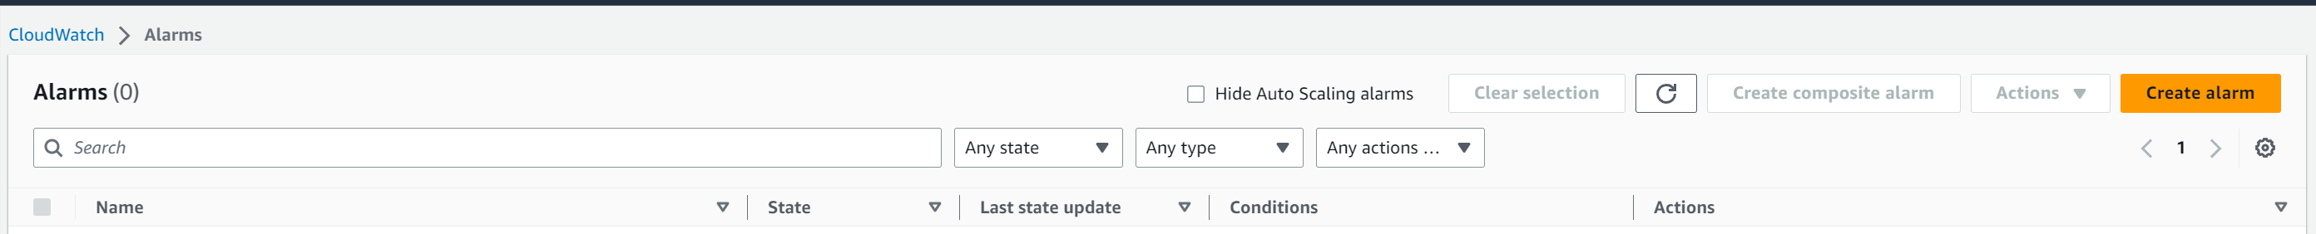

Checked alarms. ^^

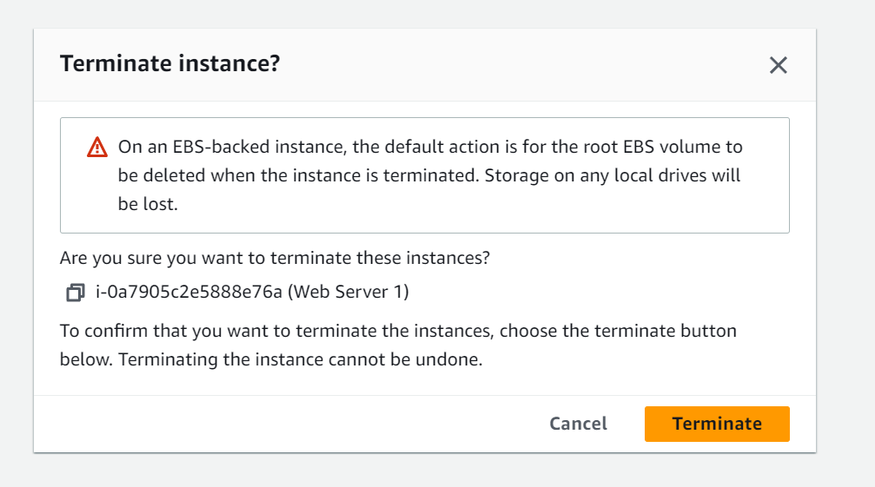

Terminating instance. ^^

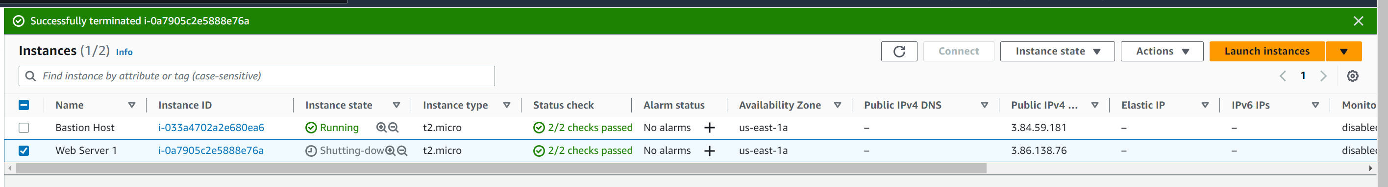

Instance terminated successfully. ^^^^^

**Problems –** I didn’t have any problems with these three labs except for one problem in lab five, which was a spot I got stuck on. It was when I was creating a subnet group.

**Conclusion -** In closing I learned how to do the second three Amazon AWS labs and completed all three of them. Within the labs I learned how to do tasks from creating security groups to databases. These three labs were overall very helpful and instructional.